Element of Design: Line

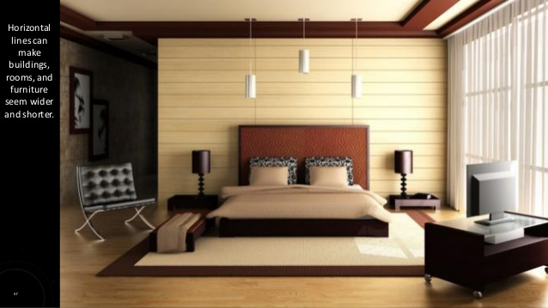

Line is the most basic element of design. It establishes direction and helps determine the mood of a room. The predominant line in this design is horizontal which helps create a feeling of calm and rest in this bedroom. Horizontal lines are seen in the wall, the bed, the rug and the bedside tables.