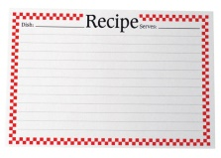
Name__________________________ Date ______________ Period ______
Kitchen Math
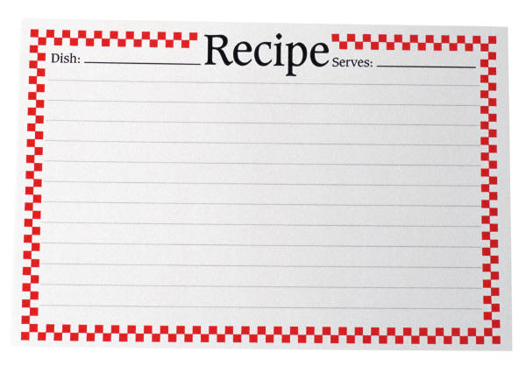
Use the Kitchen Conversion Sheet and the cookie recipe below to convert the recipe so you will make only 1½ dozen cookies. Write your answers in the first box. In the second box, convert the recipe to make 6 dozen cookies.
Shortbread Cookies
Makes about 3 dozen cookies
¾ c. shortening ½ t. salt
¾ c. granulated sugar ½ t. baking soda
¼ c. beaten eggs 2 c. cake flour
½ t. vanilla extract food coloring
¼ t. butter flavoring
- Preheat oven to 350 º.
- In a mixing bowl, using and electric mixer, cream together the shortening and granulated sugar until fluffy.
- Gradually add the eggs, vanilla extract and butter flavoring until well blended.
- Sift together salt, baking soda, and cake flour and gradually add to shortening, sugar, egg mixture.
- Add food coloring to the desired color.
- On a lightly floured surface, roll dough to a thickness of ¼ - ½ inch. Using lightly floured cookie cutters, cut out desired shapes and place on an ungreased cookie sheet.
- Bake in a preheated oven for 8 – 10 minutes.
- Cool until firm, then remove to a cooling rack until completely cooled.

Kitchen Math (page 2)
Shortbread Cookies
To make 1 ½ dozen cookies
________ shortening ________ salt
________ granulated sugar ________ baking soda
________ beaten eggs ________ cake flour
________ vanilla extract food coloring
________ butter flavoring

Shortbread Cookies
To make 6 dozen cookies
________ shortening ________ salt
________ granulated sugar ________ baking soda
________ beaten eggs ________ cake flour
________ vanilla extract food coloring
________ butter flavoring

